### **Website Content Presentation**

### Client: Mariana Suetsugu, Shiota

### Presentation Date: 07/10/2023

### Contact for More Information:

### Email: gustavomottadeveloper@gmail.com

### Phone: +55 11 91177-8861

### Copyright © 2023 [BringUp]. All rights reserved.

### Logotipo Descrição gerada automaticamenteAcademy of

### Japanese

### Culinary

### Innovations

# Become a Forefront Chef of Japanese in just weeks!

Discover the Art of Japanese Cuisine “Washoku” in Japan with Intensive Cooking Courses!

100% In-person event in Japan

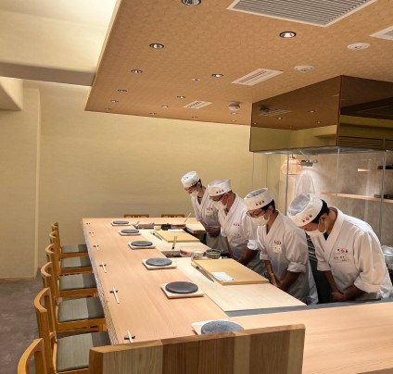Welcome to Academy of Japanese Culinary Innovations, where culinary excellence meets the art of innovation. We are a renowned institute recognized for providing exceptional courses that attract chefs looking for the highest quality and creativity.

With instructors who have extensive experience in forefront restaurants in different culinary fields, we offer comprehensive curriculums that cover everything from the classic fundamentals to the latest trends and unique techniques in modern Japanese cuisine. When you join our academy, you will have the opportunity to explore premium ingredients, hone your presentation skills, and develop a deep understanding of the harmony of flavors and characteristics of Japanese cuisine**, *ALL IN JUST WEAKS!***

Join us on this unique and innovative journey, where tradition and innovation meet to create extraordinary dishes.

# Hiroaki Uto

**CEO: BRINGUP Corporation, Japan Principal: Academy of Japanese Culinary Innovations**

・Founder of short-term practical cooking schools, "Foodservice University" and "Foodservice Academy."

・After working at a management consulting firm, ventured into the foodservice industry in 2003, becoming Vice President, oversaw the growth of the company into a multi-brand enterprise with 60 stores, including yakitori, yakiniku, cafes, seafood, and patisseries, and expanded through franchise development.

・In 2008, established a subsidiary focusing on foodservice talent services, offering nationwide career support for job placement and career consulting for over 20,000 industry 　　　　　　　professionals.

・In 2014, founded the short-term cooking school, "Inshokujin-Daigaku (Cooks’ Academy)," and assumed the role of principal, producing over 1,000 graduates.

・In 2015, opened "Sushi Chiharu," a restaurant operated exclusively by graduates of "Foodservice University," which became ***the quickest Michelin Guide entry in the domestic sushi industry*** and gained media attention due to coinciding with statements from “Horiemon” Mr. Takafumi Horie, a prominent opinion-leader in Japan, on social media.

・In 2019, stepped down from the companies he founded, including the parent company, subsidiary, and the Cooks’ Academy, to support the establishment of a subsidiary for an IT company specializing in foodservice (listed on the Tokyo Stock Exchange).

・In 2020, founded BringUp Co., Ltd., and assumed the role of CEO.

・In 2022, in partnership with G-FACTORY Co., Ltd. (listed on the Tokyo Growth Market), established the short-term practical cooking school "Inshoku-Juku (Foodservice Academy)" and became its school director under a one-year contract where he oversaw the setup and operation.

・Currently, he actively communicates through TV and other media channels and has produced numerous Japanese cuisine chefs who excel worldwide.

Our Instructors

* **窓の前にいる男性

  自動的に生成された説明**

## Wakako Takamatsu

**CEO, BringUp Okinawa Co., Ltd.**

**Owner of Yakiniku Kappo Takamatsu.**

**Chief Administrator: Academy of Japanese Culinary Innovations**

・After managing self-owned restaurants and providing restaurant consulting services, led the development of a nationwide career support business for chefs, being responsible for overseeing career consulting for over 20,000 individuals in this business.

・Has been involved with “Inshokujin-Daigaku” (Cooks’ Academy) and “Inshoku-Juku” (Foodservice Academy) since their inception, contributing to curriculum development and operations.

・Excels in customer service and restaurant operation guidance, often serving as an instructor in "Hospitality" classes.

・Certifications: Communication Skills Development Organization, Level 1 Psychological Counseling and Level 1 Coaching. Also holds a chef's license, is a sommelier certified by the Japan Sommelier Association, and is a food analyst.

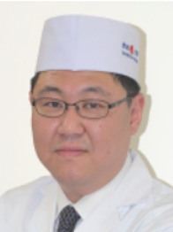

## Takahiro Hoshikawa

**Instructor: Sushi, All-Around (General) Japanese**

・Having served as a supervisor in the Japanese culinary division of a globally expanding hotel, he has a wide range of experience from budget offerings to luxury establishments.

・Dedicating to a cuisine that brings out the best in ingredients and conveying a sense of “heart” and “way of being” as individuals, warmly guides numerous students and juniors.

・Has been making global impacts, including producing high-end sushi restaurants in San Diego, USA.

## Kazuhiro Tanaka

**Instructor: Yakitori, All-Around (General) Japanese**

・Employed for 11 years as a chef of Japanese cuisine and kaiseki at "Arima Grand Hotel" and "Japanese Cuisine Yuki" at NakanoBo company.

・Has worked as a yakitori, Japanese cuisine and sushi cooking instructor for 30 years at institutions such as the Kobe International Culinary Pastry School and the Hiroaki Uto cooking school.

・Also has experience in managing Japanese cuisine and sushi restaurants.

・Holds a culinary license, specialized licenses in Japanese cuisine, sushi cooking and noodle cooking, as well as certifications as a poultry processing and hygiene manager and a pufferfish (fugu) handling license.

・In addition, has qualifications in Japanese gastronomic etiquette, Urasenke tea ceremony, Sencha tea preparation and Kado (flower arranging) from the Sogetsu school.

## Rikisai Miyajima

**Instructor: Ramen**

・Since 2001, has worked as a consultant specializing in ramen, focusing on assisting in new openings and the revitalization of ramen establishments in financial difficulties.

・Contributed to specialized books and was widely publicized in the media, leading to the creation of the title “Ramen Producer”.

・Serves as an instructor at custom ramen schools located in Tokyo, Yokohama and Osaka, offering individualized instruction.

・Has produced over 1,200 students from national and international locations.

## Koji Iwashina

**Instructor: Soba and Udon**

・Chef - Artisan Soba Shop “Gen-san” (Katsushika Ward)

・Owner - Chef - Restaurant "Sanmi-Saishoku Iwakou" (Matsudo City, Chiba Prefecture)

・Chef - Soba Shop "Sarashina-Nunoya" (Hamamatsucho, Minato District)

・Chef - Soba Store “Sarashina-Nunoya・World Trade Center” (Hamamatsucho, Minato District)

・Has 27 years experience in making soba noodles.

・Currently presides over a soba noodle making workshop that celebrated 7 years in 2022 with more than 400 sessions.

## Sushi Course

Duration: 20 days

Schedule:

Day 1 - 7:

* Handling 5 types of fish
* Preparation of sushi rice (shari)
* Sushi roll mold

Day 8 - 14:

* Handling 10 different types of fish
* Sushi roll mold
* Lecture on restaurant operations

Day 15 - 20:

* Handling 5 different types of fish
* Basic Japanese dishes with fish
* Visit to the fish market (subject to availability)
* practical training of fish aging on “Tsumoto-Method”

Tuition Fee: US$11.600 (dollars)

## Yakitori Course

Duration: 15 days

Schedule:

Day 1 - 5:

* Chicken handling
* Skewering techniques
* Charcoal grill

Day 6 - 10:

* Cut from all 21 different parts of the chicken
* Basic Japanese dishes with chicken
* Lecture on restaurant operations

Day 11 - 15:

* Preparation of side dishes in the restaurant
* Visit to a processing facility (subject to availability)

Tuition Fee: US$9.300 (dollars)

## Ramen Course

Duration: 10 days

Schedule:

Day 1 - 3:

* Ramen broth
* Clear and white soup base
* Roast pork
* Seasoned boiled egg
* Menma (seasoned bamboo shoot)

Day 4 - 7:

* Pork and beef bones
* Seafood-based broth
* Advanced coverage
* Preparing homemade pasta

Day 8 - 10:

* Lecture on restaurant operations
* Development of original Ramen products
* Halal and herbal preparations

Tuition Fee: US$8.100 (dollars)

## All-Around (General) Japanese Course

Duration: 25 days

In this course, you will learn the fundamentals and applications of Japanese cuisine, “Washoku,” as a whole.

Schedule:

Day 1 - 8:

* Knife handling
* Dashi (broth) and basic seasonings
* Preparation of sushi rice

Day 9 - 17:

* Sushi roll mold
* Basic fish handling (6 types)
* Lecture on restaurant operations

Day 18 - 25:

* Making soba noodles and sauce
* Basic Japanese cuisine
* Manufacture of traditional bento

Tuition Fee: US$17.400 (dollars)

## Uma imagem contendo Ícone Descrição gerada automaticamenteUma imagem contendo Ícone Descrição gerada automaticamenteTela de celular com texto preto sobre fundo branco Descrição gerada automaticamente com confiança médiaUma imagem contendo Ícone Descrição gerada automaticamenteWhy take the Washoku intensive cooking course?

## Image gallery

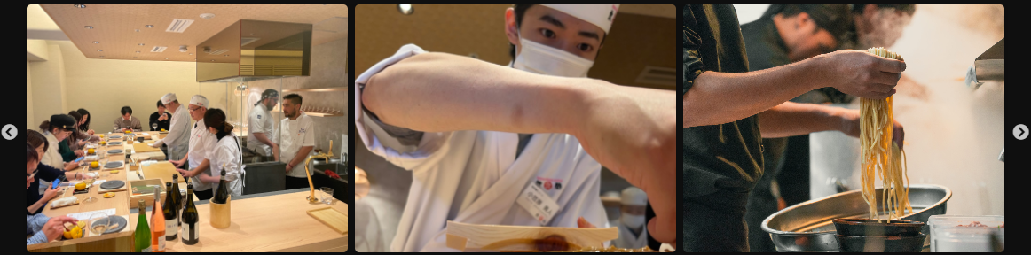

“Affiliated store 'Shuhari', operated as part of the

curriculum by students”

Student crafting a culinary masterpiece

Preparation of the pasta

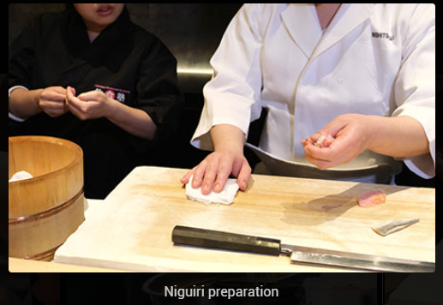Niguiri Preparation

Niguiri Preparation

Niguiri Preparation

Learn more about the courses

**Forms**

Name:

E-mail:

Phone number:

Choose the course: (It's possible to choose more than 1 course)

Sushi Course

Yakitori Course

Ramen Course

All-Around (General) Japanese Course

Tell us a little about your expectations for the course: